|  |  |  |  |
| --- | --- | --- | --- |
| H:\AA SCIENCE 6TH GRADE NOTES\PH Ch. 1 Matter\Elements, Compounds, and Mixtures\Balloon Molecules Pictures\photo 1.JPG | H:\AA SCIENCE 6TH GRADE NOTES\PH Ch. 1 Matter\Elements, Compounds, and Mixtures\Balloon Molecules Pictures\photo 2.JPG | H:\AA SCIENCE 6TH GRADE NOTES\PH Ch. 1 Matter\Elements, Compounds, and Mixtures\Balloon Molecules Pictures\photo 3.JPG | H:\AA SCIENCE 6TH GRADE NOTES\PH Ch. 1 Matter\Elements, Compounds, and Mixtures\Balloon Molecules Pictures\photo 4.JPG |
| H:\AA SCIENCE 6TH GRADE NOTES\PH Ch. 1 Matter\Elements, Compounds, and Mixtures\Balloon Molecules Pictures\photo 5.JPG | H:\AA SCIENCE 6TH GRADE NOTES\PH Ch. 1 Matter\Elements, Compounds, and Mixtures\Balloon Molecules Pictures\photo 6.JPG | H:\AA SCIENCE 6TH GRADE NOTES\PH Ch. 1 Matter\Elements, Compounds, and Mixtures\Balloon Molecules Pictures\photo 7.JPG | H:\AA SCIENCE 6TH GRADE NOTES\PH Ch. 1 Matter\Elements, Compounds, and Mixtures\Balloon Molecules Pictures\photo 8.JPG |

Example:

Name ___________________________

Date ______________ Period ______

Key

Balloon = ______________

Balloon Color = ______________

Tape = ____________________

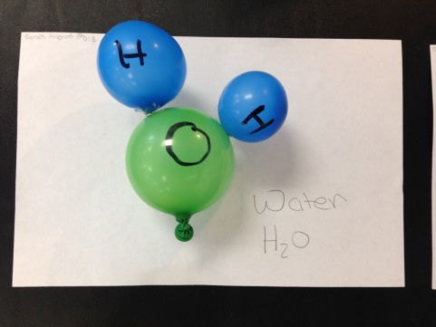

**Water H20**

**Compound:**

Because 2 Hydrogen atoms chemically bonded to 1 Oxygen atom