Targets | With  Help | On My  Own | Teach It
- I can list the 4 states of matter
- I can explain the three general properties of solids (shape, volume, particle movement)
- I can explain the three general properties of liquids (shape, volume, particle movement)
- I can explain the three general properties of gases (shape, volume, particle movement)
- I can explain the difference between gases and plasmas.
- When given a diagram of the different states of matter, I can identify them all, and label the points at which each matter changes states (freezing, melting, condensation, vaporization)
- I know an element is a pure substance
- I know how an element is represented by chemical symbols
- I know what a compound is and how it is represented by a chemical formula
- I can identify the difference between elements, compounds, and mixtures
- I can describe the difference between an Element and a Compound.
- I can recognize the limited number of elements that make up Earth’s crust, oceans, atmosphere and living matter.

Key Terms: Make and Study Flashcards for these Vocabulary Terms
Atom |  | Substance |  | Chemistry |  | Compound |  | Element
Gas |  | Liquid |  | Matter |  | Mixture |  | Molecule
Plasma |  | Solid |  | Solution

Target 6:
Target 5:

Target 7:

An Element is ____________________________.
Target 8:
_____ Gold _____ Sodium _____ Chlorine _____ Hydrogen
_____ Iodine _____ Lead _____ Carbon _____ Nitrogen
Target 9:

1. A compound is __________________________________________________________________________.

2. What is the difference between No and NO?
________________________________________________________________________________________

3. Identify the following as element symbols or compound formulas:

________________________Au ________________________H₂O ______________________H₂SO₄

________________________NO ________________________No ______________________Pb

Target10:

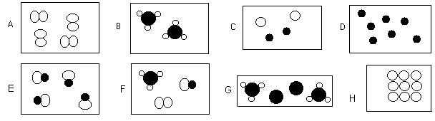

Compounds
Elements
Target 11:

Target 12:

- List the major (not trace) elements in the human body. __________________________________________________________________
- List the major (not trace) elements in Earth’s crust: ____________________________________________________________________
- List the major elements in Earth’s oceans:
____________________________________________________________________
- List the major elements in Earth’s atmosphere:
____________________________________________________________________

Go back to the lists above and highlight one element in the body, crust, and oceans that is unique to that list and isn’t in any other list above.

