Earth’s Structure Table of Contents
____________________________________________________________________________________________________________________________________________________________________________________________________________________________________________________________________________________________________________________________________________________________________________________________________________________________________________________________________________________________________________________________________________________________________________________________________________________________________________________________________________________________________________________________________________________________________________________________________________________________________________________________________________________________________________________________________________________________________________________________________________________________________________________
Title
LTs
Page #

Earth’s Structure Learning Targets

Page # | Target | With Help | On My Own | Teach It
 | I can correctly make a model of Earth’s interior.
 | I can correctly label the inner core on a model of Earth.
 | I can correctly label the outer core on a model of Earth.
 | I can correctly label the mantle on a model of Earth.
 | I can correctly label the asthenosphere on a model of Earth.
 | I can correctly label the lithosphere on a model of Earth.
 | I can correctly label the crust on a model of Earth.
 | I can differentiate between the lithosphere and the asthenosphere.
 | I can label the following plates on a map: Eurasian plate, African plate, Indo-Australian plate, Pacific plate, North American plate, South American plate.
 | I can write the definition of plate boundary.
 | I can describe the plate movement at divergent boundaries.
 | I can describe the plate movement at convergent boundaries.
 | I can describe the plate movement at transform boundaries.
 | I can describe the plate movement at subduction zones.
 | I can explain how convection currents in the asthenosphere cause the tectonic plate movement.
 | I can predict the major geological events that occur at divergent boundaries.
 | I can predict the major geological events that occur at convergent boundaries.
 | I can predict the major geological events that occur at transform boundaries.

Make and study flashcards for these vocabulary terms. Page numbers are in parentheses

Continental Drift (p.289-290)
Alfred Wegener (p.289)
Pangaea (Notes in Journal)
Theory of Plate Tectonics (p.284)
Plate Boundary (p.286)
Convergent Boundary (p.286)
Divergent Boundary (p.286)
Transform Boundary (p.286)
Oceanic Crust (p.273)
Continental Crust (p.273)
Arc Volcanoes (p.286)
Island Arc Volcanoes (p.286)
Subduction (p.286)
Fault (p.287)
Trench (p.286)
Rifting/Rift Valley (p.286)
Seafloor Spreading (p.287)
Asthenosphere (p.274)
Inner Core (p.276)
Outer core (p.276)
Crust (p.273)
Lava (p.306)
Lithosphere (p.274)
Magma (p.306)
Mantle (p.274)
Seismic wave (p.292)

How does this cake model the Earth’s layers?
1. Include Labels for each layer
- 2. Explain the similarities and differences between this model and Earth. ______________________________________________________________________________________________________________________________________________________________________________________________________________________________________________________________________________________________________
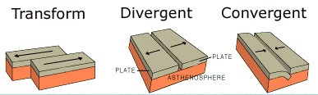

- What major geologic events occur at each of these types of plate boundaries?
Transform Boundary: __________________________________________________
Divergent Boundary: ___________________________________________________
Convergent Boundary:________________________________________________
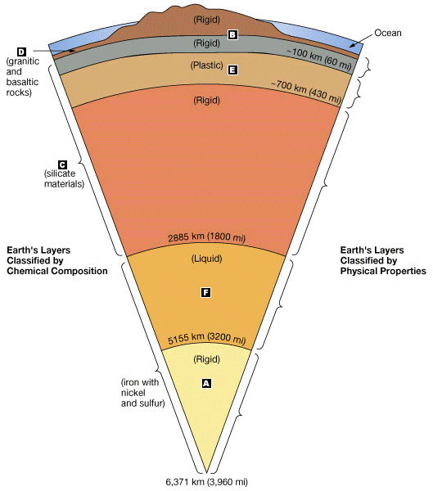
_______________________
______________________________
________________________________
______________________________
______________________________
______________________________
______________________________

______________________________

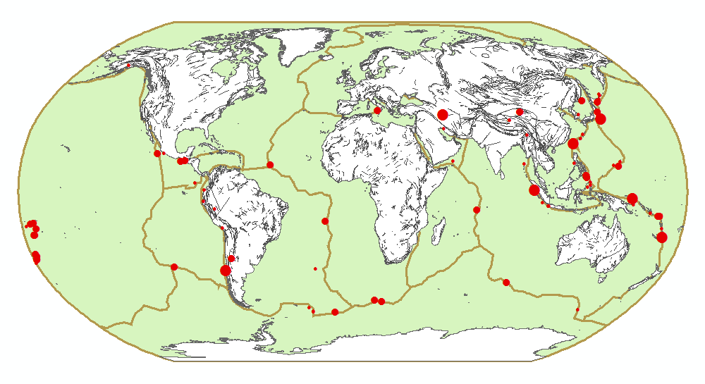
22
5
3
4
1
6
1
Himalaya Mountains

1. ______________________________________ 2. ______________________________________
3. ______________________________________ 4. ______________________________________
5. ______________________________________ 6. ______________________________________

