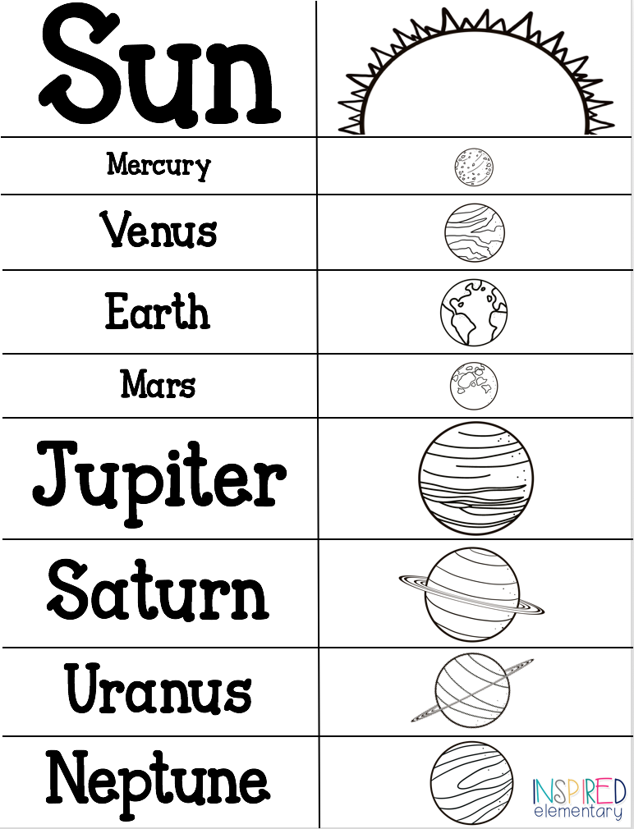

Also know as Jovian PlanetsMeaning Jupiter-like). They are the four planets farthest from the sun. They do not have solid surfaces and are made up of Hydrogen,

­­­­­­­­­­­ Helium, and Ices__________________They are much Larger than the inner planets. That’s why they are called the Gas Giants.

* **FOLD ALONG DASHED LINES**
* **WHEN YOU ARE DONE, PUT GLUE IN IS INSTRUCTION AREA AND PASE IN JOURNAL ON THE PAGE OPPOSITE “INNER PLANETS”**

**OUTER PLANETS**

Other Stuff in the Solar System:

Pluto – Dwarf Planet

Asterroids- Revolve around the sun

Meteors- Meet Earth’s Atmosphere

Comets- Have an orbit

* Discovered due to Mathematical Prediction. Astronomers suspected another planet was Affecting the Orbit of Uranus
* Smaller but Denser than Uranus
* Temp: Atmosphere -200oC Core 7000oC
* Rot 16.5 hours Rev 164 Years
* Composition- Mostly Ices and Rock
* 15% Hydrogen, Helium, and trace amounts of Methane
* Had a great storm in the southern hemisphere, The Great Dark Spot .
* Fastest winds in the solar system.
* Moons-at least 13satellites (moons).

- Have rings

–Many satellites

_ Non-Solid Surface

–Low density

–Rapid rotation

–Deep atmosphere

**Outer Planets have:**

* Temp: Atmosphere: -224oC Core4600oC
* Coldest Planet in the solar system
* Uranus is Tilted 90 o from vertical so from our perspective, it rotates top to Bottom
* Rot17 Hours Rev: 84 Years
* Composed of Hydrogen, Helium, Methane and

Ices.

* Blue appearance due to traces of Methane
* Least massive of the outer planets.
* 27 Satellites (moons)
* Very faint rings composed of black dust & boulder sized rocks
* Saturn is the second largest planet
* Less dense than water It would float
* Rot- 10.75 hours Rev29.5 years
* Composed mainly of Hydrogen, Helium, Methane, & Ammonia.
* Thick gas/Liquid atmosphere with a Tiny Rock core
* Clouds of Ammonia Ice crystals.
* Temp Atmosphere -175oC Core 11,700oC
* Rings composed of Rock, dust, and ice.
* 52 recognized moons
* Titan is Saturn’s largest Moon is only moon in solar system with an Atmosphere
* Titan has Organic compounds, atmosphere, liquid environ. that are life ingredients.
* Largest & Most MassivePlanet
* Core is hotter than the Sun
* Temp Atmosphere: -110oC Core: 36000oC
* Rot- 10Hours Rev11.87 years
* Has the Most circular Orbit
* The Fastest rotation of all planets
* Thick liquid Atmosphere, tiny solid core
* Composed primarily of Hydrogen & Helium
* Clouds of Amonia Ice Crystals
* Jupiter is Windy & Stormy
* Red Spot is a storm 4 X size of Earth
* 63 known satellites (moons)
* Galileo discovered 4 largest moons: Io Europa, Ganymede, & Callisto
* Rings are made of dust

•Also known as JOVIAN Planets (meaning Jupiter-like)

•Do not have solid surface

•Made up of HYDROGEN, HELIUM, and ICE

•Much LARGER than Inner Planets, that’s why they are called GAS GIANTS

•Have relatively

–LOW density

–RAPID rotation

–DEEP atmosphere

–HAS rings

–MANY satellites

•Have relatively

–HIGH density

–SLOW rotation

–SOLID surfaces

–NO rings

–FEW satellites

–LOW density

–RAPID rotation

–DEEP atmosphere